PHYSICS, CHEMISTRY AND APPLICATION OF NANOSTRUCTURES, 2013
EFFECT OF STRUCTURE AND SURFACE STATE OF NANOCRYSTALLINE TIN DIOXIDE ON ITS GAS SENSING PROPERTIES
E. OVODOK, M. Ivanovskaya
Research Institute for Physical Chemical Problems, Belarusian State University
14 Leningradskaya Str., 220030, Minsk, Belarus. E-mail: ivanovskaya@bsu.by
D. Kotsikau, I. ASARKO
Belarusian State University
4, Nezavisimosti Av., 220030, Minsk, Belarus
V. KORMOSH, I. ALYAKSEV
Research Institute of Analytical Technique of Uzhgorod National University
25, Mukachivska Str., 88000, Uzhgorod, Ukraine
Effect of particle size, concentration of structural defects and the presence of sulfite and sulfate groups on the response of thick-film SnO₂ sensors to CH₄ and CO were revealed. Particle size and the presence of SO-groups were found to be main parameters determining the sensitivity of SnO₂-based sensors to CH₄, while structural defects of SnO₂ layers are essential for CO detection.

Introduction
Nanosized tin dioxide is widely used as sensing layers for semiconducting gas sensors, whose work principle is based on the change in electrical resistance after contact with a test gas. Both adsorption and catalytic properties of SnO₂ are known to depend on particle size, presence of doping additives, surface state, nature and properties of adsorption centers [1–4].
Typically, chemical deposition approach assumes the preparation of SnO₂ oxide by the transformation of Sn (IV) compounds. In this work we propose to use Sn (II) sulfate as a precursor in order to obtain a SnO₂ material that differ in grain size, phase composition, microstructure, nature of defects and surface state. Hydrolysis of SnSO₄ water solution results in Sn (II) oxyhydroxide, which transforms into Sn(IV) oxide under thermal treatment. The formation of intermediate nanosized phases (SnO, Sn₃O₄) and stabilization of partially reduced tin states (Sn⁺², Sn⁺³) are possible during this process. Also, it is known that thermal decomposition of residual SO₄^{2–} ions provides a modifying effect on the state of an oxide surface, increasing its area and catalytic activity in oxidation reactions [5]. These effects are associated with changes in the nature and strength of acid-base centers on the oxide surface, and with the participation of adsorbed SO_{x}– groups in the activation of adsorption processes [6].
The effect of certain structural factors on the change of electrical conductivity of SnO₂ layers under exposure to CO–air and CH₄–air mixtures has been studied in the paper.

Experimental
The SnO₂ samples were prepared by hydrolysis of SnSO₄ water solution with hydrated ammonia. The precipitates was washed 5 times by centrifugation and exposed to ultrasonic treatment for 2 min (22 kHz). The obtained sols were dried at 50 ºC and annealed at 500–800 ºC in air.
The samples were characterized by Electron paramagnetic resonance (EPR), Fourier-transform infrared spectroscopy (FTIR) and X-ray diffraction (XRD). EPR spectra were recorded on a VARIAN E 112 spectrometer with a frequency of 9.35 GHz at 77 K. IR spectra were obtained on an AVATAR-330 (Thermo Nicolet) spectrometer in λ range 400−4000 cm^{–1}. XRD analysis was carried out on a DRON-2.0 diffractometer by using Ni-filtered Cu Kα radiation. The Sherrer equation was used for estimation of average particles size in the samples (CSR - coherent-scattering region).
Thick-film sensing layers were fabricated using the SnO₂ powders annealed at different temperatures. The powders were grinded with ethanol to form a paste. The pastes were deposited onto alumina substrate supplied with Pt-heater and electrodes. The substrates with the layers were additionally annealed at 570 °C. The sensitivity of the sensors was measured to CO (0.015% vol. %) and CH₄ (0.05 vol. %). The sensor response (G) was calculated as R_{air}/R_{gas}.

Results and Discussion

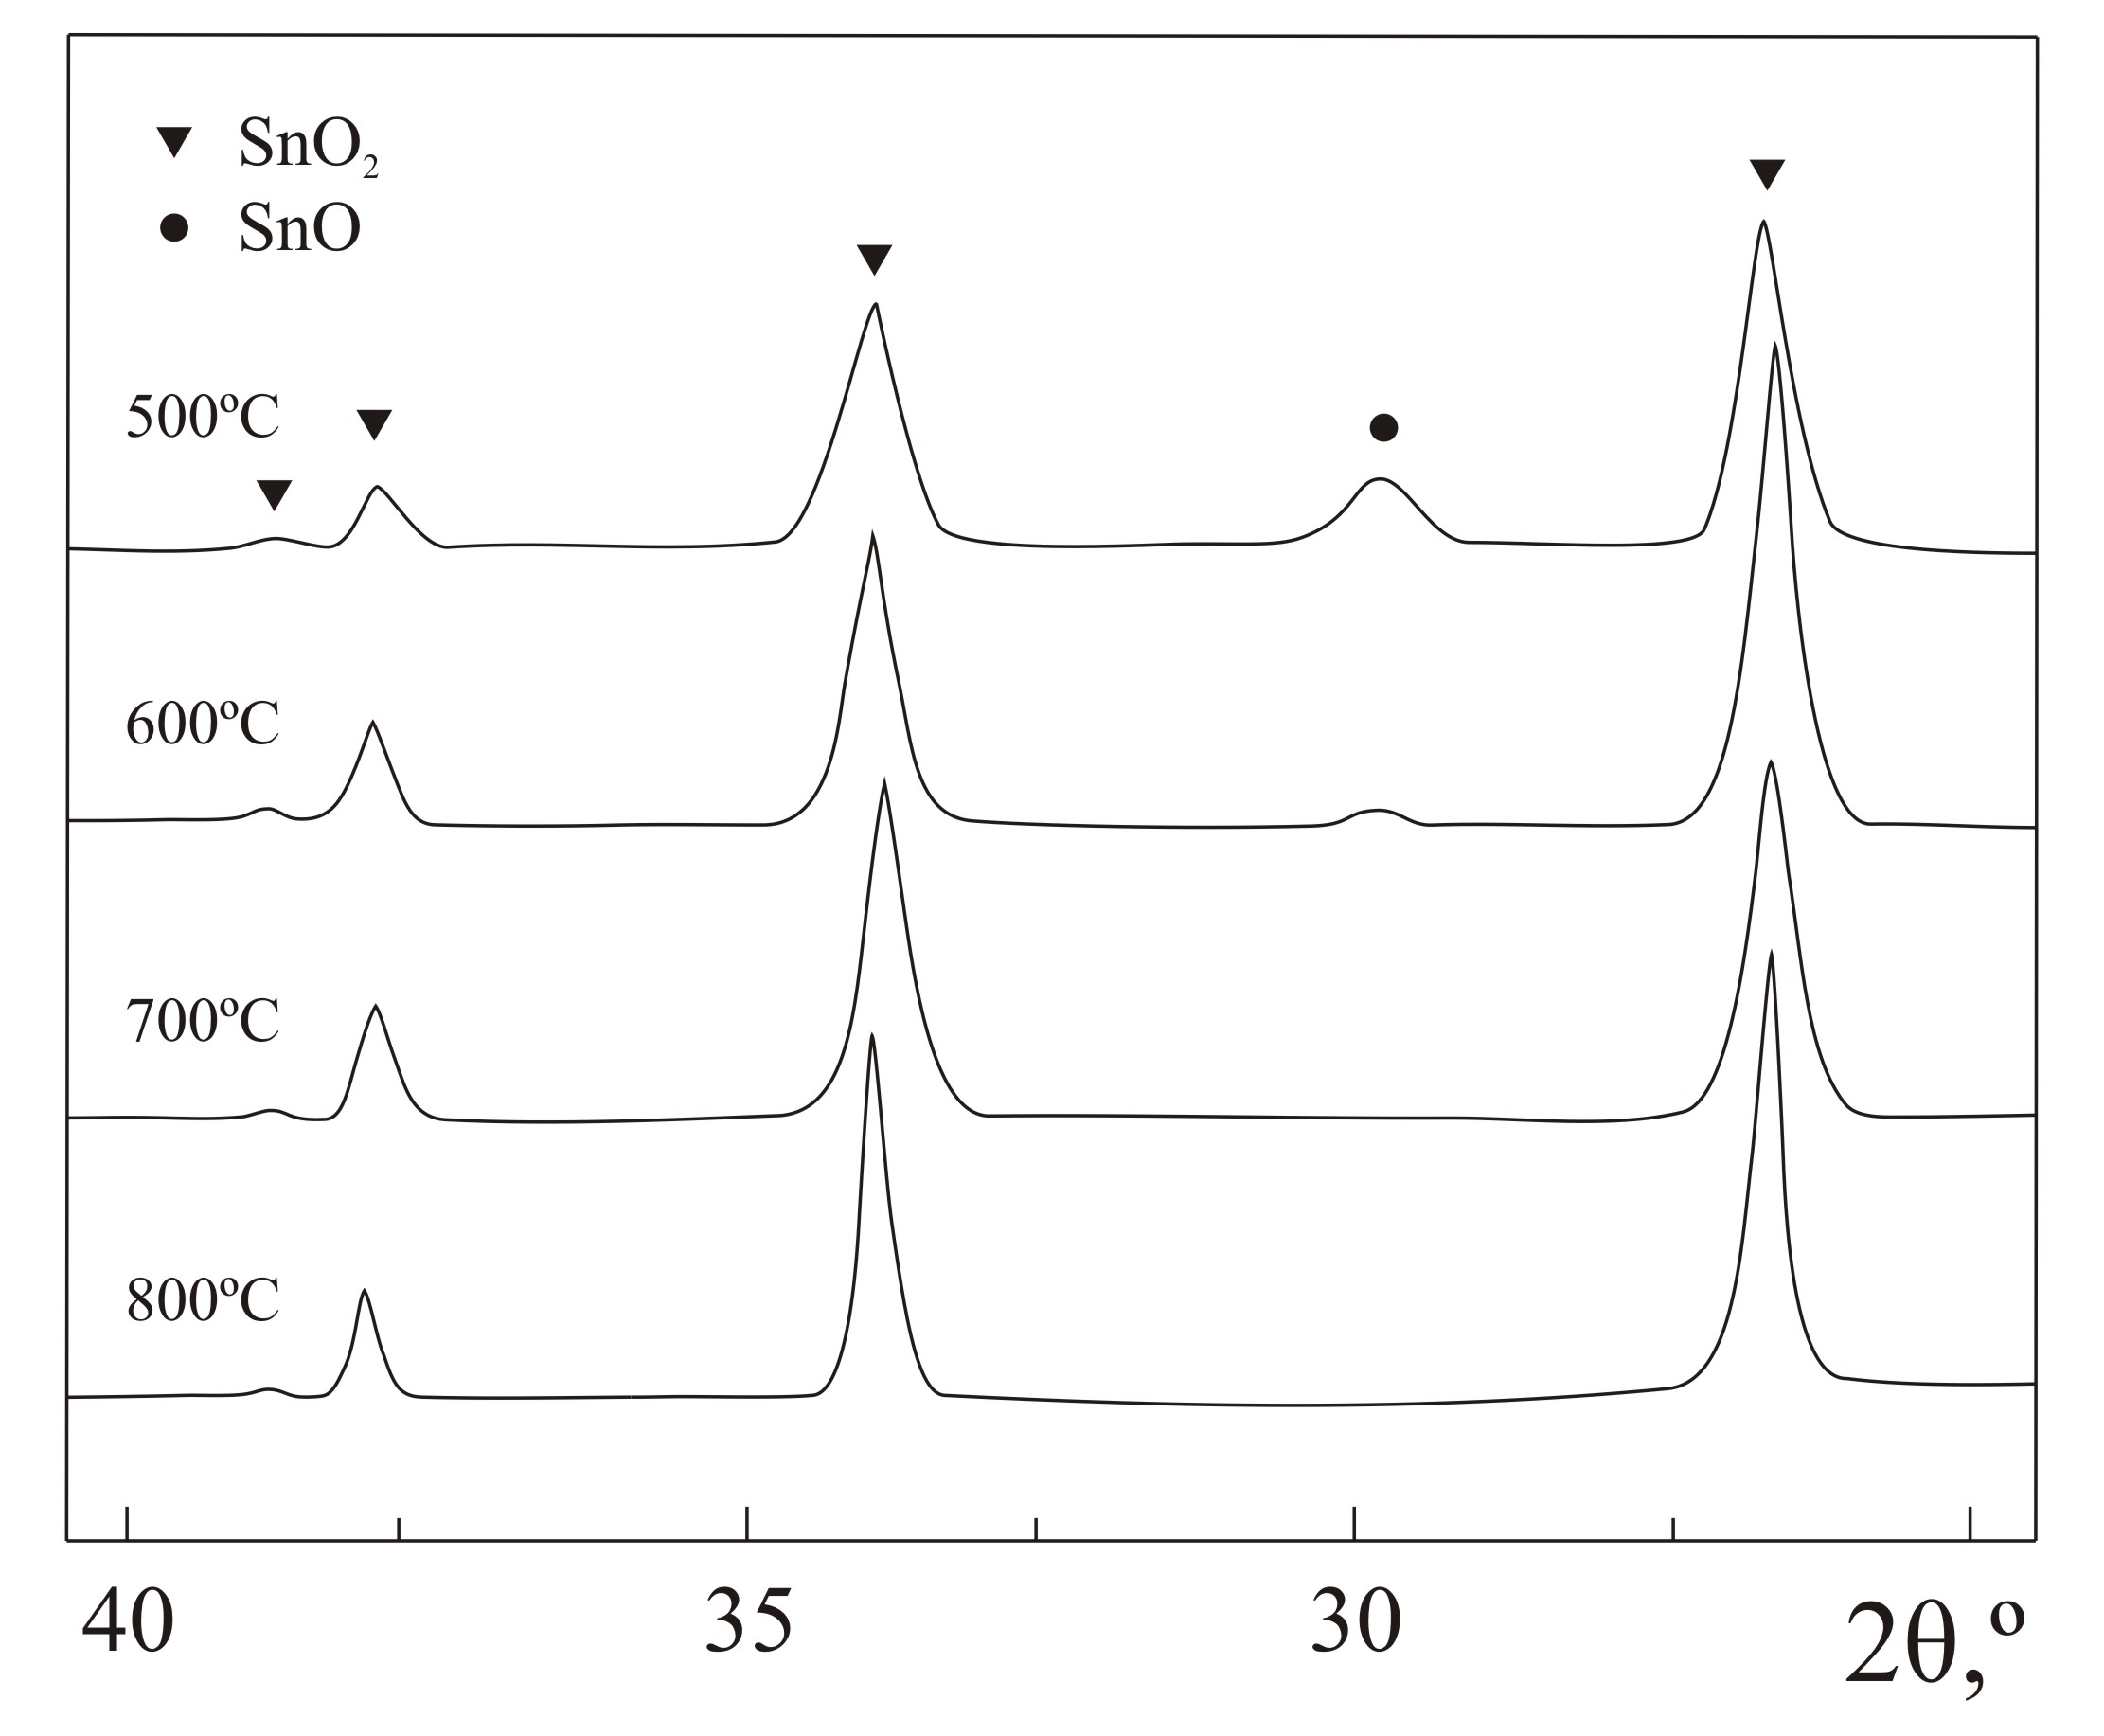
Figure 1 XRD patterns of the SnO₂ samples annealed at different temperatures.
According to the XRD data of the powder dried at 50 °C (Fig. 1) the hydrolysis product of SnSO₄ solution is Sn₆O₄(OH)₄ (a = 0,7926 nm, c = 0,9102 nm) with an admixture of SnO₂. After heating the sample at 500-800 °C SnO₂ is registered as the main phase. Unit cell parameters of the SnO₂ phase, grain size and the sensor response to CO and CH₄ are given in Table 1.
As it is seen from Fig. 2 the sensing

characteristics to CO and CH₄ of the obtained SnO₂ material depend on its annealing temperature. Thus, the sample annealed at 500 °C demonstrates the highest response to CH₄. Note that it is characterized by minimum grain size. A

Table 1. Parameters of unit cell of SnO₂ tetragonal phase, CSR size and sensor response to CO (0.015% vol.) and CH₄ (0.5% vol.)

Т_{annealing}, ºС | Phase composition | a, nm | c, nm | CSR, nm | G, (R_{air}/R_{gas})
 |  |  |  |  | СО | СН₄
500 | SnO₂, SnO* | 0.4745 | 0.3195 | 9 | 2.6 | 8.6
600 | SnO₂, SnO* | 0.4739 | 0.3186 | 31 | 3.0 | 5.5
700 | SnO₂ | 0.4762 | 0.3208 | 24 | 2.2 | 5.2
800 | SnO₂ | 0.4736 | 0.3186 | 30 | 2.3 | 4.5
* admixture

broad absorption band with maximums at 975 and 1080 cm^{–1} is registered in the IR spectra of this sample (Fig. 3). The band is attributed to ν₃(S=O) vibration in SO₃^{2–} (980, 1040 cm^{–1}) and in SO₄^{2–} (1080 cm^{–1}), thus indicating the presence of SO₄^{2–} and SO₃^{2–} groups on the oxide surface. According to the literature data, decomposition of tin (II) sulfate(SnSO₄ → SnO + SO₃) occurs at 360 °C that corresponds to the maximum of SO₃ adsorption on SnO₂ proceeding at 450° C. Heating the powder at temperatures above 600 °C leads to the removal of SO_{x}– groups. This evokes the growth of SnO₂ crystallites and, consequently, the sensitivity to CH₄ decreases.

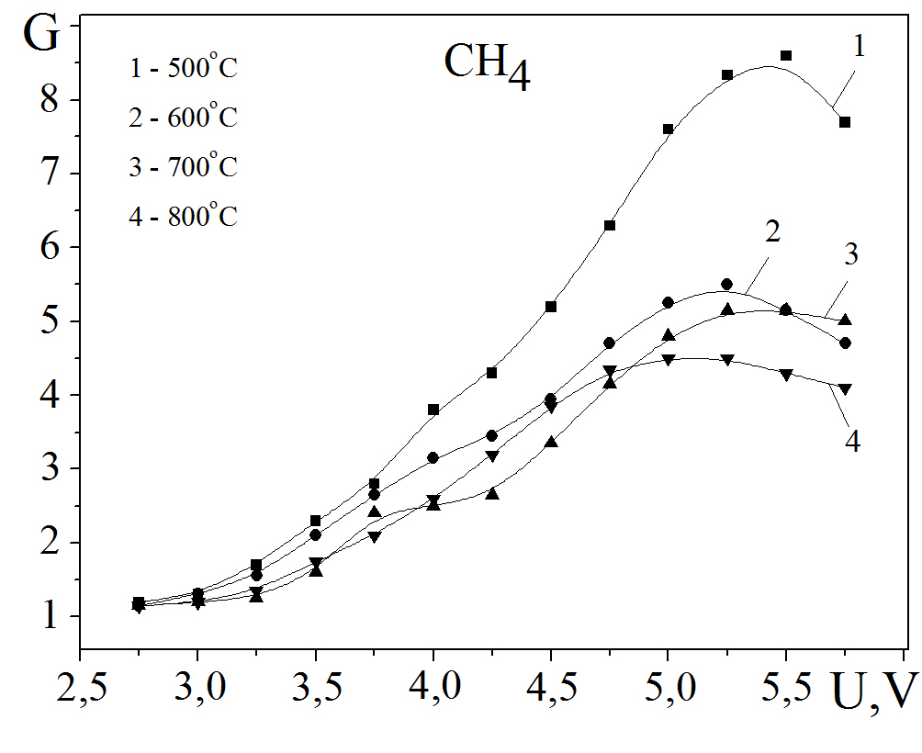 | 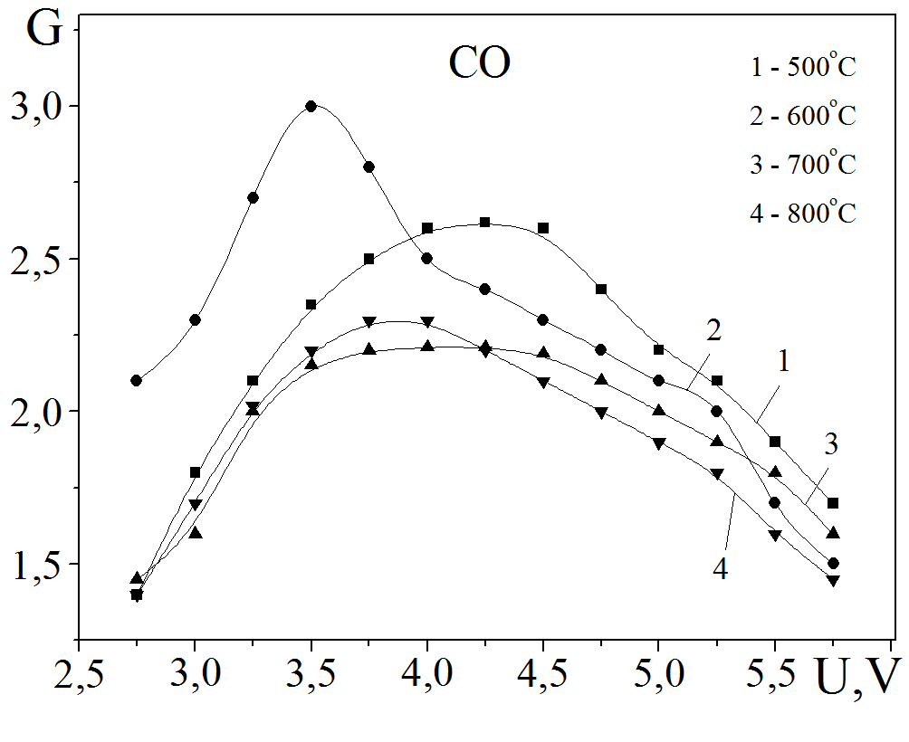
Figure 2 Sensitivity of the SnO₂ samples annealed at different temperature
to CH₄ (0.015% vol.) and CO (0,5 vol. %).

The SnO₂ sample annealed at 600° C demonstrates the highest response to CO. Note that it is observed at lower operating temperature of the sensor as compared to the maximum response to CH₄. A distinctive feature of this sample is the highest concentration of structural defects. Two types of paramagnetic

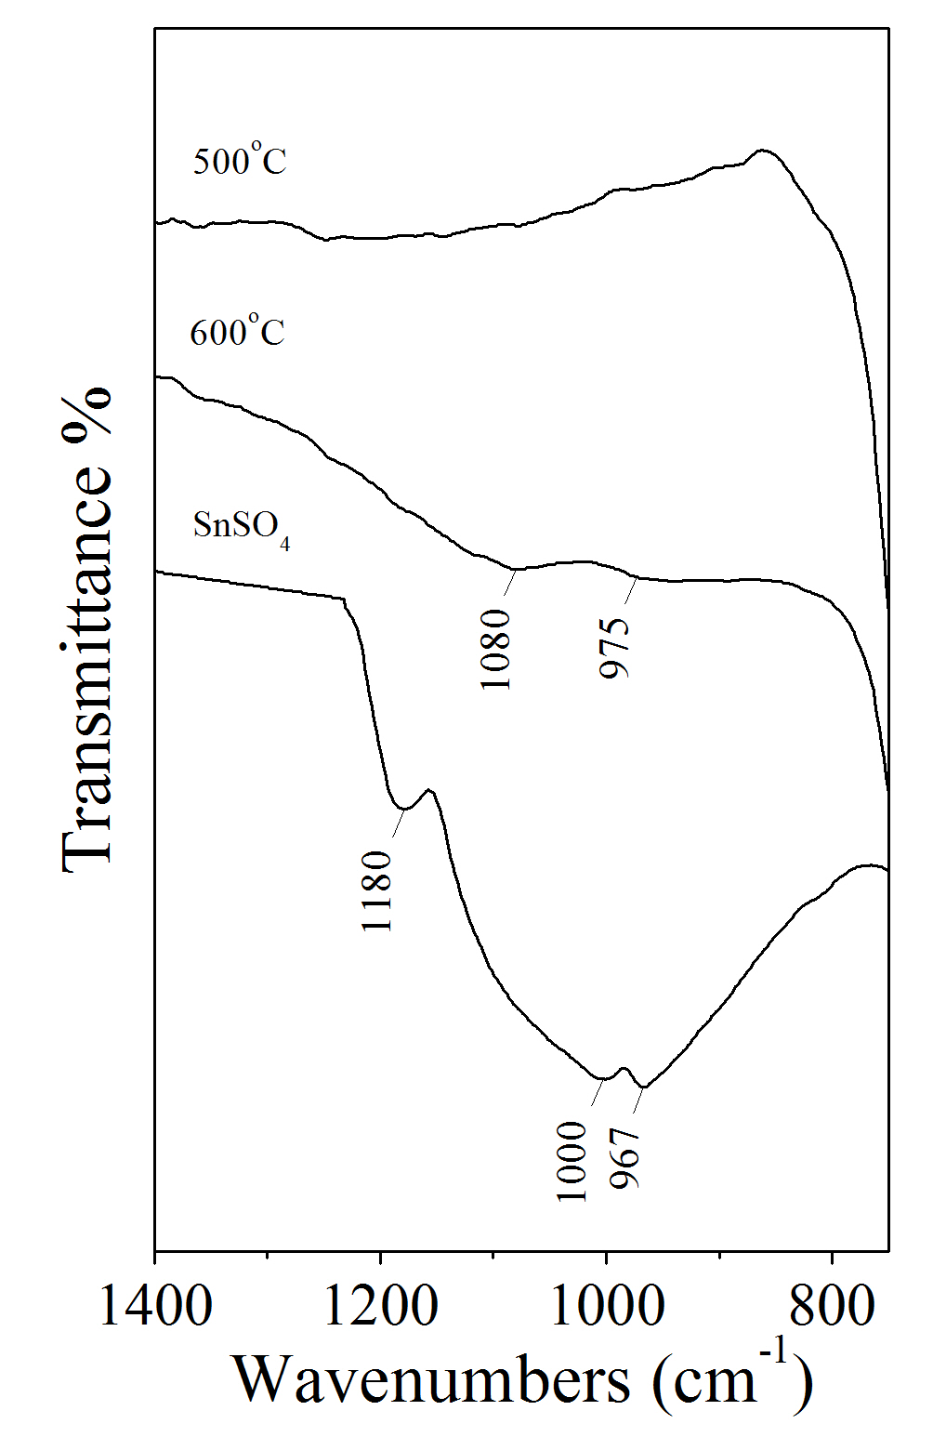
Figure 3 IR spectra of SnSO₄ powder, and SnO₂ samples annealed at 500 °C and 600 °C
centers (PC) were revealed in the SnO₂ samples by EPR spectroscopy. These centers affect the adsorption properties and electrical conductivity of semiconducting oxides. The PC with g = 1,88 are attributed to unpaired electrons localized in the s-orbital, a new orbital which consists of a linear combination of Sn⁴⁺ atomic orbitals around oxygen vacancies [Sn^{(4–δ)+}−V^{δ–}]. There is a clear correlation between the concentration of these centers in SnO₂ and its sensitivity to CO. The mentioned EPR signal has the highest intensity in the sample obtained at 600 °C. The second type of PC with g⊥ = 2,0032 and
g|| = 2,00017 is related to defects in the crystal lattice of SnO₂, where oxygen is stabilized

in O– form. This chemically active oxygen form is an effective center for CO adsorption. The O– defects can be originated in the process of partial transformation of lattice O^{2–} oxygen into single-charged state due to the charge compensation in Sn_{1–x}(Sn_{2+x})O₂.

Conclusion
The presented data support the point that the size of SnO₂ particles, chemical state of the surface, and nature of the defects play an important role in determining the adsorption and gas-sensing features of nanosized SnO₂ material. The presence of SO_{x}– groups in the oxide structure and the associated increasing in dispersion of SnO₂ oxide result in the growth of the sensor sensitivity to CH₄ more than to CO. The drop of the sensor conductivity under CO exposure depends mostly from the concentration of structural defects in the SnO₂ layer, in particular, oxygen vacancies, which act as the centers of adsorption and activation of CO and O₂ molecules.
References
1. K. Kohl, Sens. and Act. B. 18, 71 (1989).
2. S. Morrison, Sens. and Act. B. 2, 329 (1982).
3. A. Cabot, J. Arbiol, J. Morante, Sens. and Act. B. 70, 87 (2000).
4. M. Ivanovskaya, Proc. of conf. devoted to the centenary of acad. N.F. Ermolenko. (Minsk, 2000) 144.
5. V. Komarov, M. Sinilo, Vesci AN BSSR. 4, 11 (1988).
6. V. Komarov, M. Sinilo, Kin. and Kat. 29(3), 701 (1988).

