Bitcoinica Overview
Bitcoinica Overview
Event Timeline
Bitcoinica.com
Limited Partnership Structure
Bitcoinica LP Partners
General Partner
Limited Partner(s)
Employee(s)
Customers
Bank Account
Bitcoinica Server
Bitcoinica Post Mortem
Bitcoinica Terms of Service
Terms and Conditions
[1] Amendments
[2] Online Services Agreement
[3] Membership Eligibility
[4] Legal Restrictions
[5] Limited License
[6] Communications
[7] Obligations of Bitcoinica
[8] Tax collection
[9] Registration Information and Requirements
[10] Important information about customer identification
[11] Indemnity and right of set-off
[12] Limitation of Liability
[13] Risk Statement
[14] Market information
[15] Use & Access to the Site
[16] Company's rights
[17] Force Majeure
[18] Technical Problems
[19] Hyperlinks
[20] Trademarks and Copyrights
[21] Governing Law; Arbitration and Court Jurisdiction
[22] Disclosures
[23] Deposits and withdrawals
[24] Dormant Accounts Procedure
[25] Termination
[26] Software
References (incomplete)

Event Timeline

- 2011/09/08 - Bitcoinica.com created and announced by Zhou Tong under xWaylab Inc. Announcment on HN: http://news.ycombinator.com/item?id=2973313
- 2011/09/11 - Patrick Strateman hacks into Bitcoinica (ref)
- 2011/10/?? - Bitcoinica.com secretly sold to investment group (Wendon). Zhou Tong remains CEO, most actions were approved by Tihan. Wendon realized there were problems and went to the Coinlabs people but weren’t able to help or renegotiated on the deal (unsure).
- 2012/01/30 - CORE CREDIT LIMITED incorporated as a NZ Limited Company. aka Bitcoinica's 'banking partner' (an approved FSP in New Zealand)
- 2012/02/24 - Patrick Strateman announces a serious vulnerabilitiy in Bitcoinica (ref)
- 2012/03/02 - LINODE hack. 43554 BTC stolen. LP (Tihan’s fund) covers loss.
- 2012/03/27 - Bitcoin Consultancy retained to perform a comprehensive security audit.
- 2012/04/24 - CORE CREDIT LIMITED becomes operator of Bitcoinica LP. Public ANN on bitcoinmedia.com & bitcointalk.org.
- 2012/05/05 - Bitcoinica announces new NZ Bank Account for SEPA wire-transfers.
- 2012/05/?? - Paperwork was wrong and Tihan was rushing because he realized how fucked the situation really was (According to Patrick over IRC)
- 2012/05/11 - RACKSPACE hack. 18547 BTC Stolen, Full data loss. LP covers loss.
- 2012/05/15 - Post mortem posted on www.bitcoinica.com
- 2012/05/18 - Online claims process opened.
- 2012/05/25 - Genjix announces there are no database backups.
- 2012/05/30 - Genjix announces 80% payout of verified customers starting 2012/05/31.
- 2012/05/30 - CORE CREDIT LIMITED becomes BITCOINICA CONSULTANCY LIMITED.
- 2012/06/02 - Genjix announces impasse due to legal wrangling.
- 2012/06/04 - Genjix announces impasse due to bureaucratic problem.
- 2012/06/07 - Genjix claims Bitcoinica.com was losing money because of the inefficient way it was being run.
- 2012/06/07 - Genjix claims that for payments to be processed, legal authorisation from the person in charge is needed. Tihan denies being in charge, which means his parent company (Core Credit) has to authorise the payments. However Tihan is saying we don't need that.
- 2012/06/07 - Zhou Tong announces that Bitcoinica has already identified more than half of the claimed amount as "accurate".
- 2012/06/11 - Genjix claims only 5% of users have been verified
- 2012/06/13 - Genjix claims 50% payout to verified customers has started but up to now no customer has publicly confirmed receiving deposits back.
- 2012/??/?? - Online claims process closed
- 2012/??/?? - Tihan fired
- 2012/07/07 - Bitcoinica source code leaked by genjix?
- 2012/07/11 - All 50% payments stopped
- 2012/07/12 - Patrick walks away (reason unknown)
- 2012/07/13 - Bitcoinica’s MtGox account compromised: 40k USD and 40k BTC stolen (~350k USD). Hacker used leaked MtGox API key as a password in LastPass to obtain updated MtGox account password.
- 2012/07/13 - Genjix announces likely forced 30% payout cut to customers.

Bitcoinica.com

The world’s first fully-licensed advanced trading platform for Bitcoins. Bitcoinica was developed by a 17 year old Chinese student named Zhou Tong. In less than 6 months Bitcoinica.com was home to over one million dollars in assets. After 7 and a half months his advanced trading platform had traded 8.5 million Bitcoins (currently worth roughly 44 million USD).

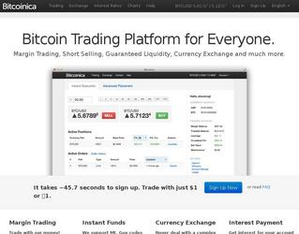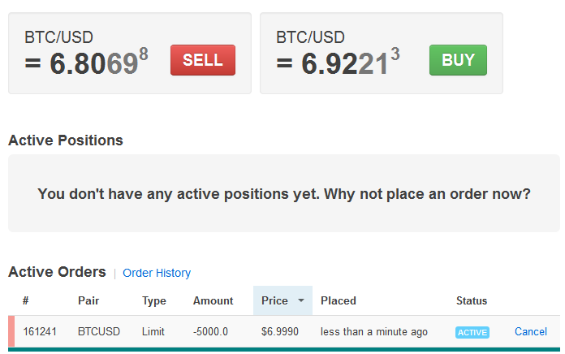

Bitcoinica allows users to make speculative bets on the fluctuations of Bitcoins. In particular, the ability to leverage trades allow users to reap higher rewards if the market turns their direction. This unique feature is enabled by automatic lending of funds between accounts behind the scenes. As a result, depositors can also make a sizable return on investment in the form of interest.

On 2012/04/24 Bitcoinica announced a new contract signed with the Bitcoin Consultancy Ltd. Bitcoin Consultancy will be taking a dominant role in the operations of Bitcoinica, ushering forward its continued safety and stable operation. - Donald Norman

source: http://bitcoinmedia.com/first-licensed-advanced-trading-platform-for-bitcoin/

Limited Partnership Structure

A limited partnership is a form of partnership similar to a general partnership, except that in addition to one or more general partners(GPs), there are one or more limited partners (LPs). It is a partnership in which only one partner is required to be a general partner.

The GPs are, in all major respects, in the same legal position as partners in a conventional firm, i.e. they have management control, share the right to use partnership property, share the profits of the firm in predefined proportions, and have joint and several liability for the debts of the partnership.

As in a general partnership, the GPs have actual authority as agents of the firm to bind all the other partners in contracts with third parties that are in the ordinary course of the partnership's business. General Partners carry more liability, and in cases of financial loss, the GPs will be liable.

Like shareholders in a corporation, LPs have limited liability, meaning they are only liable on debts incurred by the firm to the extent of their registered investment and have no management authority. The GPs pay the LPs a return on their investment (similar to a dividend), the nature and extent of which is usually defined in the partnership agreement.

source: http://en.wikipedia.org/wiki/Limited_partnership

Bitcoinica LP Partners

General Partner
BITCOINICA CONSULTANCY LIMITED (formerly CORE CREDIT LIMITED).
- A separate New Zealand Ltd company formed for the purpose of operating Bitcoinica.com.
- Has the exclusive legal authority to manage the company.
- Per standard practice, Bitcoin Consultancy entered into a non-disclosure agreement which extends to Bitcoinica's proprietary systems and processes.
- Bitcoin Consultancy members will continue to operate the business going forward. They have expressed their commitment to seeing things through.
- Bitcoinica will be offline until such time as a new platform can be built and tested with security best-practices built-in from scratch.
- Company director: Christopher Heaslip (chris@irstax.co.nz) (An accounting professional who assisted with company formation, also listed as shareholder w/ 1000 shares, 100% allocation. a nomini shareholder and director?)
- Company owners (aka 'intersango guys'):
  - Donald Norman
    - Email: donald@bitcoinicaconsultancy.co.nz)
    - Skype:
    - Nicknames: ‘incitatus’, ‘steal-city’
  - Patrick Strateman((
    - Email: patrick.strateman@gmail.com
    - Skype: patrick.strateman
    - Nicknames: ‘phantomcircuit’
  - Amir Taaki
    - Email:genjix@riseup.net
    - Skype:zgenjix
    - Nicknames: ‘genjix’
- Role: operators. shareholders?



Limited Partner(s)
- The majority limited partner in Bitcoinica Limited Partnership is an investment fund which specializes in technology start-up investments.
- Tihan Seale (tihan@splashlab.com): Investment adviser for the transfer of Bitcoinica LP, responsible for deal selection and due diligence for the fund that invested in Bitcoinica.)
- Wendon - Alleged buyer of Bitcoinica?
- Exceeded their legal obligation to bear the full cost of both the Linode hack and the Rackspace hack and have pledged their continued support in seeing this incident fully resolved.
- Role: investor. owner?



Employee(s)

- Zhou Tong (ryan@xwaylab.com): Employment status unknown, not paid for work since April 1. Has not signed official resignation and continues to assist in an unofficial capacity. Has access to the fund account with all the customer deposits (at least 75% of total valid claims are in that account)
- Role: developer



Customers

- Total customers: ~5500
- The number of claims received: ~25% less than total number of paid customers.
- Claims total net value: ~$1.1 million
- The value of claims exceed the total assets by ~35%
- Total assets value: ~$814,000
- Margin (Taking into account the original insolvency resulted from the hacks): ~15%.
- Positions: At least 100K long and 100K short open positions.

Bank Account

- Account Name: Core Credit Limited
- Address: Auckland, New Zealand
- Account Number: 26821351-USD-37
- Bank Name: ASB Bank Limited
- Bank Address: 135 Albert Street, Auckland, New Zealand
- SWIFT Code: ASBBNZ2A

Bitcoinica Server

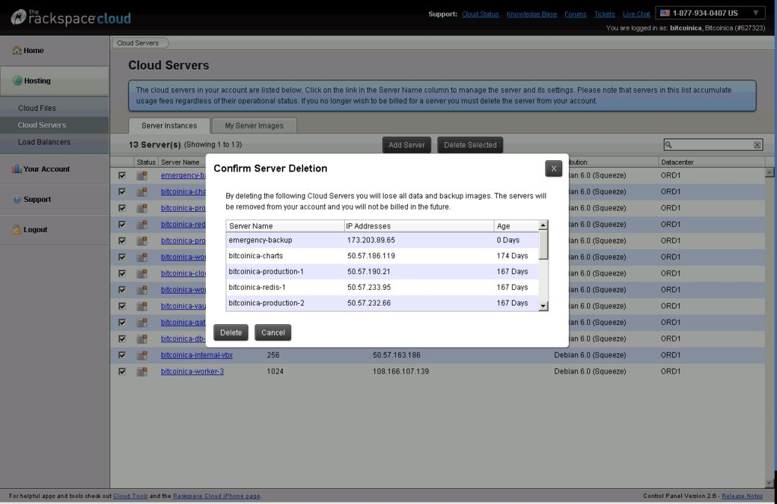

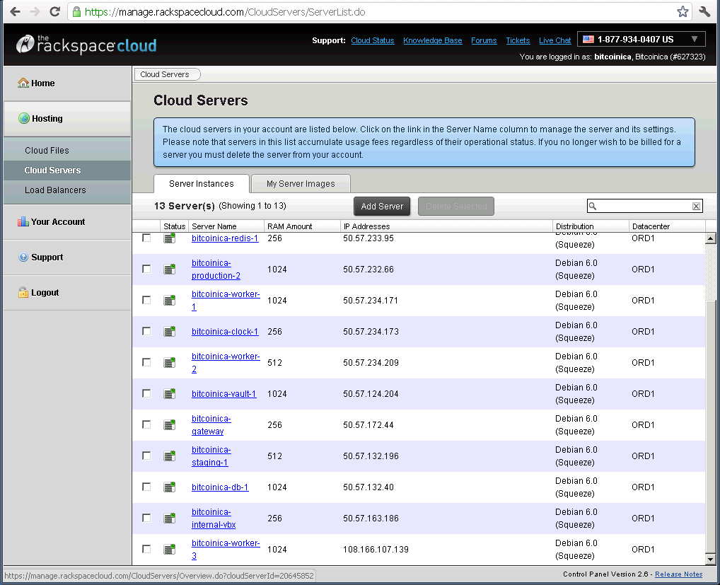

IDs:
- cloudServerId=20645852
- customerId=627323

servers:
- emergency-backup
- bitcoinica-charts
- bitcoinica-production-1
- bitcoinica-redis-1
- bitcoinica-production-2
- bitcoinica-worker-1
- bitcoinica-clock-1
- bitcoinica-worker-2
- bitcoinica-vault-1
- bitcoinica-gateway
- bitcoinica-staging-1
- bitconica-db-1
- bitcoinica-internal-vbx
- bitcoinica-worker-3

source:
- http://depositfiles.com/files/2p6zvadzs

Bitcoinica Post Mortem
As promised we are providing further details surrounding the recent security attack on Bitcoinica.
The hacker was successful able to access an email server. This gave the attacker access to info@bitcoinica.com which in turn allowed them to reset passwords with our hosting provider, Rackspace. From there, they were able to change root passwords, steal the private keys of our hosted bitcoin wallet, and compromise our online database.

In the past, Bitcoinica has been victim to the poor security practices of an irresponsible hosting provider. In this case, the fault was entirely ours. Specifically, here's how things went wrong:

- We had too many bitcoins in our online wallet.
In light of past experiences you might say this is inexcusable. You would be right. Our practice was to keep online balances to a minimal amount by periodic transfer to offline storage. However, this was a manual process and the online balance could grow quickly and unpredictably from user deposits. We should have had an automatic process or an alert system to prevent the online wallet from growing too large. Indeed, that was planned, but it didn't happen soon enough.
- Access control and server security did not get the proper attention
Since administrative email accounts can receive password reset links from Rackspace, the administrative contact should have been a secure email address, it was not. Access to this email account should have been limited to administrative personnel.
- We did not retain needed expertise fast enough
As many of you know, Bitcoinica began as a small project by a solo founder. The advanced trading experience that Bitcoinica brought to the world would not have been possible without Zhou Tong's brave innovation. In light of rapid growth, it was prudent to bring in a larger team with diverse technical specialties, including security. This occurred officially last month when the Bitcoinica Consultancy team stepped in as managers and operators of the business. A transition period ensued. A new platform was conceived which would strengthen Bitcoinica in the long term but took focus away from the present system in the short term. The recent security breach was not beyond our team's skills to prevent. We know better. But we did not address relevant issues as quickly as was needed.

So, what are we going to do about it?
- We are choosing to leave Bitcoinica offline until such time as a new platform can be built and tested with security best-practices built-in from scratch. We do not yet have a firm estimate for availability but it will most probably be measured in months.
- We will set up a process in the short term for users to withdraw their funds. Further details will be provided once we determine the best approach.
- We thank you in advance for your patience. And we humbly apologize for this incident.

Bitcoinica Terms of Service

[This is Google's cache of https://bitcoinica.com/pages/tos. It is a snapshot of the page as it appeared on 11 May 2012 09:48:18 GMT.]

Bitcoinica Terms of Service

Terms and Conditions

The following describes the terms and conditions upon which Bitcoinica LP ("Bitcoinica" or "the Company" or "we") offers access to its Web site to you the customer (hereinafter "you" or "user" or "customer") and the use of its services (hereinafter the "Agreement" or "User Agreement" or "Online Services Agreement"). This Agreement describes the conditions, risks and terms applicable to your use of services available at www.bitcoinica.com (the "Site" or "Web site"). If you have questions regarding this Agreement please contact us. You must read and agree with and accept the terms and conditions contained in this User Agreement without modification, including terms and conditions expressly set forth below as well as those incorporated by reference before continuing to be a customer of Bitcoinica. By continuing to access and/or use the Web site, you also agree to follow the Terms and Conditions of this Agreement. This Agreement is effective upon acceptance of registration for new customers, or upon receipt of e-mail notification, or online notification by other users.

[1] Amendments

By using our services you agree to be bound fully by all terms and conditions. Bitcoinica may revise or amend this Agreement at any time by posting amended terms on the Site. By continuing to trade through the platform, you agree to be bound by any revisions. When such changes to the terms & conditions are made the Company will post such changes on the Web site. All amended terms shall be effective 10 days after their initial posting on the Web site, or as of the first time that you use our services after such amendments were made, whichever is sooner. If you do not agree to be bound by the terms and conditions of this Agreement, do not use or access our services.

[2] Online Services Agreement

This Online Services Agreement is made by and between Bitcoinica and you. This Agreement applies to the Bitcoinica Web site and trading platform, as well as to the content and or software currently contained on the Web site that provides information about the exchange rate of currencies and digital assets, including bitcoin, as well as any other features, content or services that the Company may add in the future (hereinafter referred to as the "Service").

[3] Membership Eligibility

Our services may only be used by individuals or entities who can form legally binding contracts under the law applicable to their country of residence. If you do not qualify, please do not use our site. In addition, our services may only be used by individuals who have sufficient knowledge in financial matters to evaluate the risks of trading via this Site without relying on any information contained on this Site. We shall not be responsible for verifying whether you possess sufficient knowledge and/or experience, nor shall we be responsible for any damage and/or loss incurred by you as a result of insufficient knowledge and/or experience. If you do not qualify, please do not use our web site. Without limiting the foregoing, our services may not be used where they are not legal to use, and the Company reserves the right to refuse and/or cancel services to anyone at its own discretion.

[4] Legal Restrictions

You understand that laws vary throughout the world, and it is your obligation to ensure that you fully comply with any law, regulation or directive, relevant to your country of residency with regards to the use of the Web site. The ability to access our Web site does not necessarily mean that our Services or your activities are legal under the laws or regulations relevant to your country of residency. This Web site does not constitute an offer or solicitation to anyone in any jurisdiction in which such offer or solicitation is not authorized, or to any person to whom it is unlawful to make such an offer or solicitation. Access to this Web site, and the offering of services via this site may be restricted in certain jurisdictions. Users are required to inform themselves and observe such restrictions. You hereby declare that the funds deposited to your account with the Company do not originate from any criminal or illegal activity.

[5] Limited License

Bitcoinica grants you a non-exclusive, non-transferable, limited personal license to access and use its Web site (the "license"). This license is conditioned on your continued compliance with the terms and conditions of this Agreement. You agree not to resell or permit access of the Web site to others, and not to copy any materials appearing on the Web site for resale or for any other purpose to others without the prior written consent of Bitcoinica. You are responsible and bound by any unauthorized use of the site made in breach of this section. You agree to use the information received from the information systems of Bitcoinica for the purpose of executing transactions inside and within the Bitcoinica Web site only. You further agree not to use any electronic communication feature of a Service on the Site for any purpose that is unlawful, tortuous, abusive and intrusive on another's privacy, harassing, libelous, defamatory, embarrassing, obscene, threatening or hateful. The license granted under this Agreement will terminate if Bitcoinica believes that any information provided by you, including your e-mail address, is no longer current or accurate, or if you fail to otherwise comply with any term or condition of this Agreement. Upon such violation, you agree to cease accessing Services. You agree that Bitcoinica, at its sole discretion and with or without notice, may terminate your access to any or all Services, close your open transactions and remove and discard any information or content within a Service.

[6] Communications

Unless otherwise indicated, any communications or material of any kind that you e-mail or otherwise transmit through the Services, including information, data, questions, comments or suggestions (your "Communications") will be treated as non-proprietary. Bitcoinica is free to use any idea, concept, know-how or technique or information contained in your Communications for any purpose including, but not limited to, developing and marketing products. Bitcoinica is entitled, but not obligated, to review or retain your Communications. Bitcoinica may monitor your Communications to evaluate the quality of service you receive, your compliance with this Agreement, the security of the Web site, or for other reasons. You agree that this does not entitle you to any cause of action or other right. In no event will Bitcoinica be liable for any costs, damages, expenses or any other liabilities incurred by you as a result of this Communications policy.

[7] Obligations of Bitcoinica

Bitcoinica will use best efforts to supply you with the information and technical means to use its Services in a twenty-four-hour mode of operation. To the best of its abilities, Bitcoinica will fulfill all your trading orders, keep the register of your orders and of their fulfillment, and provide you with necessary extracts upon your request. Bitcoinica shall provide the following online reports:
Open Positions: Report presenting the account's open transactions.
Account Statement: Report presenting the account's balance at a given point of time.

[8] Tax collection

You acknowledge, understand and agree that Bitcoinica does not collect tax on behalf of any authority in any form or manner. Without limiting the foregoing, it is your obligation alone to calculate and pay all taxes applicable to you in your country of residence, or otherwise arising as a result of your trading activity from the use of the Company's Services.

[9] Registration Information and Requirements

When you register for the service, Bitcoinica will ask you to provide certain identifying information ("Registration"). You agree to provide true, accurate, current and complete information about yourself during the Registration process, and you also agree not to impersonate any person or entity, misrepresent any affiliation with another person, entity or association, use false headers or otherwise disguise your identity from Bitcoinica for any purpose. If you are registering as or for a business entity, you hereby declare that you have the authority to bind that entity to this Agreement. Bitcoinica will treat with care the information you entrust to the Company, in accordance with the disclosures it provides during the Registration process and in its Privacy Policy. During the Registration process you will be asked to choose a user name and password that will be used by you every time you access the Web site to use the service. For your protection and that of other Web site users, you should not share your Registration information (including your password and username) with another person or business entity for any purpose including, but not limited to, facilitating access and unauthorized use of the Service. You alone are responsible for all acts or omissions that occur within the Web site through the use of your Registration information. If you believe that someone has used or is using your Registration information, user name or password to access any Service without your authorization, you should notify our Customer Support immediately.

[10] Important information about customer identification

Procedures for opening a new account

To help governments fight the funding of terrorism and money laundering activities, the applicable laws require that all financial institutions shall obtain, verify, and record information about each person who opens an account. When you open an account, we ask that you provide your name, address and other information that will allow us to identify you. We may also ask to see your Passport or other identifying documents.

Privacy Policy

Bitcoinica is committed to protecting the confidentiality of any customer's information, which it may acquire during the course of providing its services. It is the Company's policy not to disclose customer's information to non-affiliated third parties, except with the explicit prior consent of the customer or when required by law. The Company is providing this Privacy Policy to help you understand how we protect the privacy of financial and other non-public personal information about you.

Information We Collect

We may collect non-public personal information from you from the following sources:
Information we receive from you on applications or other forms;
Information about your transactions with us
Categories of Information We Disclose

We do not disclose any non-public personal information about our customers, or our former customers, to anyone, except as required by law and for authentication of the client's identity.
Confidentiality and Security

We limit access of non-public personal information about our customers to company agents who need to know such information in order to provide service to your account. In order to safeguard your non-public personal information, we maintain physical, electronic and procedural safeguards which comply with or exceed the requirements of the [New Zealand Privacy Act 1993](http://www.legislation.govt.nz/act/public/1993/0028/latest/DLM296639.html).

Privacy statement

Bitcoinica views its customers' privacy and the protection of information concerning them, to be of prime importance. We store and process your information on computers located in data centers managed by third party specialists. In addition, we use industry accepted encryption techniques to further protect your data. If you object to how we handle your information, please do not use our services. We shall not sell or rent your personal information to third parties for any purposes and we shall only use your information as described in our Privacy Policy.

[11] Indemnity and right of set-off

The customer hereby agrees to indemnify and hold harmless Bitcoinica, its directors, officers, employees or agents from and in respect of any loss, damage, liability, cost or expense that it may suffer or incur by reason of the Customer failing to discharge its obligations under or acting in breach of any of the terms and conditions herein contained or as a result of any breach of any applicable laws or regulations. In the event that there is any liability of the Customer to Bitcoinica its directors, officers, employees or agents under the indemnity provisions of the clause hereinabove, Bitcoinica shall have the right to set-off that amount against any balance held to the credit of the account opened by the Customer with Bitcoinica.

[12] Limitation of Liability

IN NO EVENT SHALL BITCOINICA, ITS OFFICERS, DIRECTORS OR EMPLOYEES BE LIABLE FOR LOST PROFITS OR ANY SPECIAL, INCIDENTAL OR CONSEQUENTIAL DAMAGES ARISING OUT OF OR IN CONNECTION WITH OUR WEB SITE, OUR SERVICES OR THIS AGREEMENT (HOWEVER ARISING, INCLUDING NEGLIGENCE) EXCEPT AS STATED IN THIS AGREEMENT. THE LIABILITY OF BITCOINICA, ITS OFFICERS, DIRECTORS OR EMPLOYEES, TO YOU OR ANY THIRD PARTIES IN ANY PROVEN CIRCUMSTANCE IS LIMITED TO THE AMOUNT OF MONEY YOU TRANSFERRED OR DEPOSITED IN YOUR ACCOUNT AT BITCOINICA IN RELATION TO THE TRANSACTION GIVING RISE TO SUCH LIABILITY. In the case where you make funds available for trading via a voucher, "coupon code", or similar from another financial service, banking institution or exchange, you acknolwedge that you are providing Bitcoinica access to those funds for trading purposes only and that the originating financial institution is the holder of such deposits. Bitcoinica is not liable for any loss if such institutions fail in honoring withdrawal of customer funds.

[13] Risk Statement

You agree to use the Web site at your own risk. Without limiting the foregoing, the financial services contained within this site are suitable only for customers who are able to bear the loss of all the money they invest, and who understand the risks and have experience in taking risks involved in financial transactions of this nature. Prices of international currency prices and other assets traded at Bitcoinica are highly volatile and difficult to predict. Due to such volatility, no Service offered on our Web site may be considered as a safe trade. Subject to market conditions, Stop Orders shall be executed either at the exact exchange rate selected by the customer, where the amount will be calculated automatically. A transaction of that nature shall be executed as soon as the distinctive ("indicative") exchange rate is found on the financial information systems which, including the Company's spread, is either identical to the order given by the customer, or indicates an identical amount of loss declared by the customer. The calculation of the price to be paid (or the payout to be received) for trades on this site, at the time the trade is made, will be based on the Company's best estimate of market prices and the expected level of interest rates, implied volatilities and other market conditions during the life of the trade, and is based on a complex arithmetic calculation. This calculation will include a spread in favor of the Company. The trade prices (or the payout amounts) offered to customers, may differ substantially from prices available in the other markets where such items are traded, due to the spread favoring the Company in the price calculation system referred to above.

[14] Market information

Bitcoinica may make available to you through one or more of its Services a broad range of financial information that is generated internally or obtained from agents, vendors or partners ("Third Party Providers"). This includes, but is not limited to, financial market data, quotes, news, opinions and reports, graphs or data. ("Market Information"). Market Information provided on these Web pages is not intended as investment advice. Bitcoinica does not endorse or approve the Market Information, and we make it available to you only as a service for your own convenience. Bitcoinica and its Third Party Providers do not guarantee the accuracy, timeliness, completeness or correct sequencing of the Market Information, or warrant any results from your use or reliance on the Market Information. Market Information may quickly become unreliable for various reasons including, for example, changes in market conditions or economic circumstances. Neither Bitcoinica nor the Third Party Providers are obligated to update any information or opinions contained in any Market Information, and we may discontinue offering Market Information at any time without notice. You agree that neither Bitcoinica nor the Third Party Providers will be liable in any way for the termination, interruption, delay or inaccuracy of any Market Information. You will not "deep-link", redistribute or facilitate the redistribution of Market Information, nor will you provide access to Market Information to anyone who is not authorized by Bitcoinica to receive Market Information.

[15] Use & Access to the Site

You shall be responsible for providing and maintaining the means by which to access the Web site, which may include, but is not limited to, a personal computer, and internet access equipment. You shall be responsible for all access and service fees necessary to connect to the Web site and assume all charges incurred in accessing such systems. You further assume all risks associated with the use and storage of information on your personal computer or on any other computer through which you will gain access to the Web site and the services (hereinafter referred to as "computer" or "your computer"). You represent and warrant that you have implemented and plan to operate and maintain appropriate protection in relation to the security and control of access to your computer, computer viruses or other similar harmful or inappropriate materials, devices, information or data. You agree that Bitcoinica will not be liable in any way to you in the event of failure of or damage or destruction to your computer systems, data or records or any part thereof, or for delays, losses, errors or omissions resulting from the failure or mismanagement of any telecommunications or computer equipment or software. You will not transmit to or in any way, whether directly or indirectly, expose Bitcoinica or any of Bitcoinica's online service providers to any computer virus or other similarly harmful or inappropriate material or device. A trade is completed when the trade has been authorized, the premium (or the margin, as the case may be) has been calculated and payment has been verified. You agree to be fully and personally liable for the due settlement of every transaction entered into under your account with the Company. You are responsible for ensuring that you alone control access to your account, and that no other person is granted access to trading on the Web site using your account. In any case, you alone remain fully liable for any and all positions traded on your account, and for any transactions entered into the Site for your account. You agree to indemnify the Company fully in respect to all costs and losses whatsoever as may be incurred by the Company as a result, direct or indirect, of your failure to perform or settle such a transaction. You agree that in the case that any trade is executed prices that do not reflect its market prices, or that is executed an abnormally low level of risk (the "mispricing") due to an undetected programming error, bug, defect, error or glitch in our Web site software or any other reason resulting in mispricing (for the purpose of this section the "error"), Bitcoinica reserves the right to cancel such transactions upon notifying you of the nature of the computer error that led to the mispricing. You have a duty to report to the Company any problem, error or suspected system or other inadequacies that you may experience.

[16] Company's rights

Bitcoinica reserves the right to suspend the operation of this site or any part or sections of it. In such an event, Bitcoinica may, at its sole discretion (with or without notice), close out the customers' open trades at prices it considers fair and reasonable at such a time and no claims may be entertained against the Company in connection thereto. Bitcoinica may, at its sole discretion, impose volume or other limits on Customer accounts. Trade payouts shall be determined by Bitcoinica by reference to the daily values reported on this Web site relevant to the data received by the Company, subject to the proviso that Bitcoinica shall have the right to make corrections to such data in the event of mispriced or typographically incorrect data.

[17] Force Majeure

You agree that Bitcoinica will not be liable in any way to you or to any other person in the event of force majeure, or for the act of any Government or legal authority, or for the failure of or damage or destruction to its computer systems, data or records or any part thereof, or for delays, losses, errors or omissions resulting from the failure or mismanagement of any telecommunications or computer equipment or software. The parties shall be released of all responsibilities for partial, full or non-fulfillment, as well as for improper fulfillment of the obligations under this Agreement, if such non-fulfillment or improper fulfillment was a result of extraordinary events, which occurred after this Agreement was concluded and which the party could not either foresee or prevent (natural calamities, wars, armed conflicts etc.).

[18] Technical Problems

You understand that while the Internet and the World Wide Web are generally reliable, technical problems or other conditions may delay or prevent you from accessing the Web site. Bitcoinica shall not be liable, and you agree not to hold or seek to hold Bitcoinica or any of its agents or service providers liable, for any technical problems, system failures and malfunctions, communication line failures, equipment or software failures or malfunctions, system access issues, system capacity issues, high Internet traffic demand, security breaches and unauthorized access, and other similar computer problems and defects. Bitcoinica does not represent, warrant or guarantee that you will be able to access or use the Web site at times or locations of your choosing, or that Bitcoinica will have adequate capacity for the Web site as a whole or in any geographic location. Bitcoinica does not represent, warrant or guarantee that the Web site will provide uninterrupted and error-free service. Bitcoinica does not make any warranties or guarantees with respect to the Web site and its content, including but not limited to, warranties for merchantability or fitness for a particular purpose. Without limiting the foregoing Bitcoinica will not be responsible for an impossibility to execute orders and requirements due to failures in the operation of informational systems caused by technical faults, which are beyond its control.

[19] Hyperlinks

Bitcoinica may provide a link to other sites that are controlled or offered by third parties. Such link to a site or sites is not an endorsement, authorization, sponsorship or affiliation with respect to such site, its owners or its providers. Bitcoinica cautions you to ensure that you understand the risks involved in using such sites before retrieving, using, relying upon or purchasing anything via the Internet. Links to these Web sites are provided solely for your convenience, and you agree that under no circumstances will you hold Bitcoinica liable for any loss or damage caused by use of or reliance on any content, goods or services available on other sites.

[20] Trademarks and Copyrights

All content, trademarks, services marks, trade names, logos and icons are the property of Bitcoinica or its affiliates or agents and are protected by copyright laws and international treaties and provisions. You agree not to delete any copyright notices or other indications of protected intellectual property rights from materials that you print or download from the Web site. You will not obtain any intellectual property rights in, or any right or license to use such materials or the Web site, other than as set out in this Agreement. Images displayed on the Web site are either the property of Bitcoinica or used with permission. You agree not to upload, post, reproduce or distribute any information, software or other material protected by copyright or any other intellectual property right (as well as rights of publicity and privacy) without first obtaining the permission of the owner of such rights and the prior written consent of Bitcoinica. Nothing contained on the Web site shall be construed as granting, by implication, estoppels, or otherwise, any license or right to use any trademark without the written permission of Bitcoinica and/or such third party that may own the trademarks. Your use of the trademarks, or any other content of the Web site, except as provided herein, is strictly prohibited.

[21] Governing Law; Arbitration and Court Jurisdiction

This Agreement shall be governed by and interpreted in accordance with the laws of New Zealand, without regard to conflicts of law principles thereof. This is the case regardless of whether you reside or transact business with Bitcoinica anywhere else in the world. If any part of this Agreement is unlawful, void or unenforceable, that part will be deemed severable and will not affect the validity and enforceability of any remaining provisions. The parties recognize electronic and magnetic recordings as evidence when settling disputable matters, in order to state any facts concerning the obligations for trading operations in the Services market. Binding Arbitration: For any Claim (excluding Claims for injunctive or other equitable relief) where the total amount of the award sought is less than $10,000, you or Bitcoinica may elect to resolve the dispute through binding arbitration conducted in person, on-line or based solely upon written submissions where no in-person appearance is required. In such cases, the arbitration shall be administered in accordance with New Zealand law or any other established Alternative Dispute Resolution provider mutually agreed upon by the parties. Any judgment on the award rendered by the arbitrator may be entered, exclusively, in any court located within New Zealand. Exclusive Court Jurisdiction: Alternatively, you agree to submit to the personal and exclusive jurisdiction of the courts located within New Zealand to settle any dispute, which may arise in relation thereto.

[22] Disclosures

The services provided under this Agreement, are provided by Bitcoinica LP, a company incorporated under the laws of New Zealand, registered with the New Zealand Companies Registry.
It is important that you be fully aware of the following points:

- Trading may be subject to a Fee if specified on the site. Bitcoinica via the Bitcoinica Trading platform shall collect such Fee from the free balance in your account held with Bitcoinica. In the event there are not sufficient funds in your free balance to cover such fee(s), you herby agree that Bitcoinica may charge, at its sole discretion, such fee(s) from other means of payment provided to Bitcoinica.
- If Bitcoinica is unable to collect such fee(s), Bitcoinica reserves the right to close part, or all, of your open positions. You shall be liable for promptly paying all fee(s), even if all margins previously deposited by you have been lost.
- The high level of leverage effect possible in conducting transactions stems from the fact that it is only necessary to pay relatively modest margins or guarantees in relation to the scope of the trade.
- The result of the above is that even a slight fluctuation of the market could mean substantial gains when these fluctuations are in your favor, but that could also mean considerable losses if the fluctuations are to your detriment.
- No system exists that could assure you that transactions should bring you great benefits, nor is it possible to guarantee, that your transactions will yield favorable results.
- Because some available markets are illiquid as compared with other financial and exchange markets, the market conditions might at times render the execution of an order or of a limit order at a stipulated price impossible.
- The amount you could lose in a transaction carrying limited risk will never be more appreciable than that which you can lose in transactions having no pre-determined limit on loss. Nevertheless, even though the extent of the losses could be subjected to an agreed upon limit, the risk of incurring losses could be higher, and that loss could occur in a relatively short period of time.
- It is possible that some unfavorable situations on the market could occur, in a relatively short period of time, resulting in the TOTAL LOSS of your investment. Since deposit of an additional guarantee is not obligatory in this case, Bitcoinica reserves the right to close the outstanding balances without the customer's consent.
- The risk information presented here does not reflect all of the risks as well as other important aspects intrinsic to trading. Therefore, before starting to trade, you should learn the specifics of trading in currency markets in detail.
- You should conclude an Agreement for opening and/or closing transactions only if you are absolutely sure of the size of its possible risk and consequences, and if you understand in detail the scope and range of your rights and obligations.
- Phone call recording: Bitcoinica may record, at its sole discretion, telephone calls made from and to its offices. You hereby agree that telephone calls made, either by you contacting Bitcoinica, or when being contacted by Bitcoinica, may be recorded by the Company.

[23] Deposits and withdrawals

Wire Transfers: When depositing by a Bank Transfer, as required by anti money-laundering regulations, you are required to use only one bank account, which is in your name. An authentic SWIFT confirmation or Transfer Confirmation, showing the origin of the funds, may be required by Bitcoinica. Failure to submit such SWIFT/Confirmation may result in the return of the deposited amount, hence preventing the deposit of such pending amounts to your Bitcoinica account. Any withdrawal of funds, from your Bitcoinica account to a bank account, can only be refunded to the same bank account that the funds were originally received from.
Alternative payment methods (e-wallets; money transfer services; internet payment vendors; etc.): when depositing funds using a facility other than Banks, you agree to, and acknowledge being bound by, the regulations and rules of such service, including, but not limited to, fees and other restrictions. Bitcoinica, at its sole discretion, may execute withdrawals to a facility other than the facility used for the original deposit, in accordance with Company and Anti money-laundering regulations.

[24] Dormant Accounts Procedure

Bitcoinica client accounts in which there have been no transactions (trading / withdrawals / deposits), for a set period of 12 months, will be considered by Bitcoinica as being dormant accounts.
Dormant accounts may be charged an annual maintenance fee of US$25 or the full amount of the free balance in the account if the free balance is less than US$25. There will be no charge if the free balance is zero. Consequently, all accounts with a zero free balance will be closed.

[25] Termination

Bitcoinica may exercise full discretion in modifying or discontinuing any part or whole of this Agreement at any time without cause.

[26] Software

You acknowledge and agree that Bitcoinica makes no warranty whatsoever that any software (the "Software") downloaded onto your computer equipment from or through the website or elsewhere will be compatible with, or operate without interruption on, your computer equipment, nor does Bitcoinica warrant that the Software is or will be uninterrupted, error free or available at all times. You further understand and agree that your download and/or use of the Software may expose you to risks associated with the download and/or use of software that may not be compatible with your computer equipment. You hereby agree to accept such risks, including, but not limited to, failure of or damage to, hardware, software, communication lines or systems, and/or other computer equipment. Bitcoinica expressly disclaims any liability with respect to the foregoing, and you hereby agree to fully indemnify, defend and hold harmless Bitcoinica from any and all damages, liabilities, losses, costs and expenses that may arise therefrom.
About - API - FAQ - System Status - Terms - Privacy - AML - Contact - Help
© 2011-2012 Bitcoinica
support@bitcoinica.com
+1 (408) 899-5564

References (incomplete)
- Core Credit & Bitcoinica Consultancy Registration: http://www.business.govt.nz/companies/app/ui/pages/companies/3715077
- Bitcoinica LP Registration: http://www.business.govt.nz/fsp/app/ui/fsp/version/searchSummaryCompanyFSP/FSP207625/4.do?noReturn=true
- Forbes announcement of Registration: http://www.forbes.com/sites/jonmatonis/2012/04/21/bitcoinica-registers-in-new-zealand-for-bitcoin-margin-trading/
- Bitcoin Consultancy Announment: http://bitcoinmedia.com/first-licensed-advanced-trading-platform-for-bitcoin/
- Payout updates: https://bitcointalk.org/index.php?topic=84042.0
- Emergency ANN: https://bitcointalk.org/index.php?topic=81045.0
- Zhoutong posts: https://bitcointalk.org/index.php?action=profile;u=38455;sa=showPosts
- Genjix posts: https://bitcointalk.org/index.php?action=profile;u=1931;sa=showPosts
- Phantomcircuit posts: https://bitcointalk.org/index.php?action=profile;u=4534;sa=showPosts
- Chatlog: http://pastie.org/4096261

